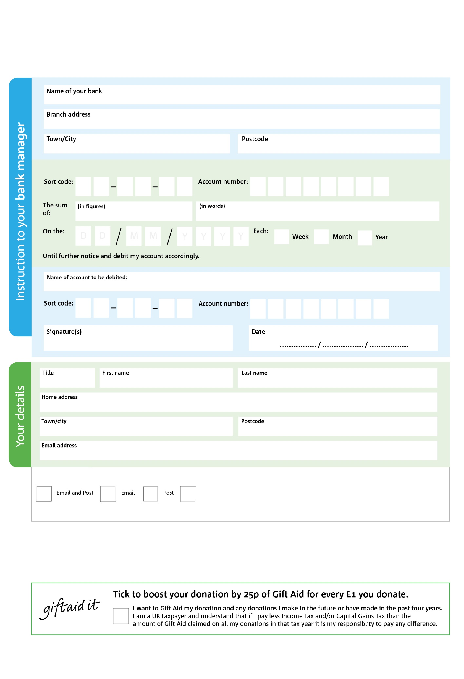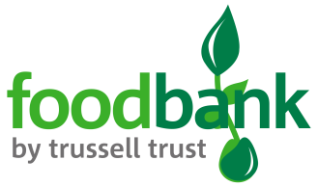

POSTAL ADDRESS: North Bristol Foodbank, 286 Filton Avenue, Bristol, BS7 0BA

**Please pass this form onto the foodbank, using the foodbank’s address at the bottom, who will save a copy for their records. They will then send it onto your named bank or building society.**

5

V

8

V

5

V

1

V

4

V

6

V

5

V

6

V

9

9

2

9

8

0

We would love to keep you up to date with information about North Bristol Foodbank. Please tick your preference:

You can change your preferences any time by contacting us on 01179791399 or emailing us at info@northbristol.foodbank.org.uk

I do not wish to receive future communications from XXXX Foodbank

Please pay North Bristol Foodbank,

**Data protection**

North Bristol Foodbank is committed to protecting your privacy and will process your personal data in accordance with the Data Protection Act 1998. North Bristol Foodbank collects information to keep in touch with you and supply you with information relating to our work. North Bristol Foodbank will never sell or pass your details to anyone who isn’t directly working on our behalf.

**Standing Order Mandate**

**Northbristol.foodbank.org.uk**

Reg. Charity No: 1157499 | Reg. in England & Wales

You can change your preferences any time by contacting us on XXXXXXXXXXX or emailing us at XXXX@XXXXXXXXXX.foodbank.org.uk

I do not wish to receive future communications from XXXXXX Foodbank