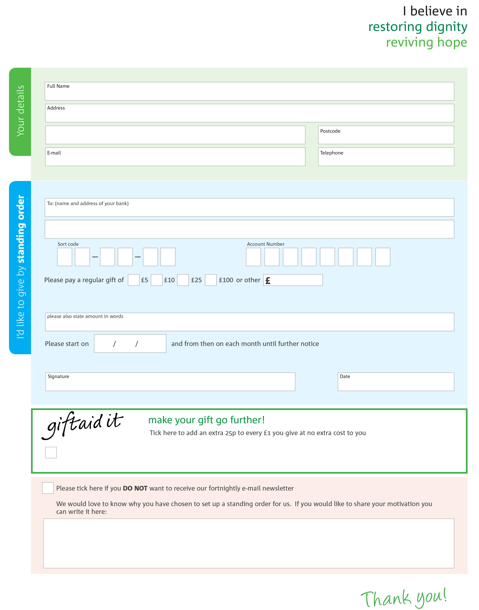
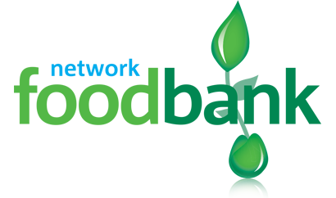
To North Bristol foodbank each month,
This cancels any previous standing order instructions to North Bristol foodbank
Yes, I pay tax in the UK. Please treat all donations I make or have made to North Bristol foodbank for the past four years as gift aid donations until further notice.
I confirm I have paid or will pay an amount of Income Tax and/or Capital Gains Tax for each tax year (6 April to 5 April) that is at least equal to the amount of tax that all the charities or Community Amateur Sports Clubs (CASCs) that I donate to will reclaim on my gifts for that tax year. I understand that other taxes such as VAT and Council Tax do not qualify. I understand the charity will reclaim 25p of tax on every £1 that I give.
North Bristol foodbank’s bank details:
Address: The Cooperative Bank, PO Box 250, Skelmersdale, WN8 6WT
Sort code: 08-92-99
Account number: 65641585
Reg. Charity No: 1157499 | Reg. in England & Wales
Please send your completed form to
North Bristol Foodbank
286 Filton Avenue
Horfield
Bristol, BS7 0BA

_{northbristol.foodbank.org.uk}

